University of North Florida

Predicting Land Surface Temperature Trends

Using Remote Sensing Data

Jamy De Vries, Kenneth Leung
Moses Lwanga, Khanh Linh Lieu
CAP 3784
Dr. Sandeep Reddivari
April 30, 2025
Abstract
The land surface temperature has served as an important parameter in climate change indications for quite a long time. The use of remote sensing, especially satellite data, becomes useful for the observation and measurements of temperature time series from space. The in-depth study presented here is about the visualization and forecasting of surface temperatures collected from the European Space Agency (ESA) for two major objectives:
- Visualization over a time scale of a year by yearly patterns of land surface temperature.
- The use of historical temperatures to predict future temperatures using an ARIMA model.
The dataset is the annual record of global land surface temperature kept in NetCDF format. A graphical user interface was developed to allow users to select a year, plot out the relevant land surface temperature map, and forecast temperature trends for the next decade. This project demonstrates the historical land surface temperature data concerning future predictions and makes climate data accessible and understandable through effective visualization and modeling.

Introduction
Climate change is today an enormous universal issue with many implications for daily life. The most pronounced signs of this change are increases in global temperature. According to NASA Earth Observatory in 2009, satellite data on temperature patterns on large areas of the Earth's surface have been available to scientists since the 1970s. One major type of satellite data is Land Surface Temperature (LST) data. It measures the temperature of the Earth rather than the temperature of the air above it. LST data helps to infer what kind of places are warming or cooling down on the Earth's surface. Land Surface Temperature is an ESA Climate Change Initiative, measuring many worldwide surface temperatures concerning time and location. The dataset is presented in the NetCDF (.nc) file format, a standard file type for storing enormous scientific datasets. We will employ the ESA LST dataset to practice downloading, cleaning, visualizing, and building simple predictive models of land surface temperatures. By working with this data set, we will examine land surface temperature patterns and use some simple forecasting techniques to study future trends further.
Data Preprocessing
The Land Surface Temperature dataset is a dataset collected by the Earth observation satellite by the European Space Agency Climate Change Initiative. This dataset contains annual global land surface temperature data and is available in NetCDF (.nc) format.
The general pre-processing steps consist of the following:
- Organizing the files into a structural folder path: Data/temps/neodc/esacci/land_surface_temperature/data/SSMI_SSMIS/L3C/v2.33/yearly
- Extracting the year from each filename using regular expressions (re package in Python).
- Building a mapping of file to date (date_file_map).
- Selecting only the first slice (isel(time=0)) from all NetCDF files.
Tools and libraries used:

- os, re: file handling, and filename parsing.
- xarray: used for opening and handling NetCDF files.
- numpy, pandas: for numerical operations and data management.

Exploratory Analysis of the Data
An exploratory phase was conducted through a graphical user interface (GUI), where users can:
- Select a year from a dropdown menu.
- Visualize the land surface temperature map for the selected year using matplotlib.
This allowed visual inspection of the temperature distribution patterns over different years. No major data anomalies were detected during map visualization, aside from expected variations due to environmental factors and sensor limitations.
Methods
Visualization:
- A Python Tkinter GUI was built for interactive selection and plotting.
- The first variable was plotted using matplotlib based on the selected year.
Forecasting:
- ARIMA (AutoRegressive Integrated Moving Average) model (order (1,1,1)) was fitted to the historical mean LST values.
- The model was built using the statsmodels Python library.
- Forecasting was performed for the next 10 years beyond the latest available year in the dataset.
Analysis of Results
A warming trend is evident in the global land surface temperature (LST) visualization from 1996 to 2020. Particularly in the mid-latitudes and polar regions, the satellite-based maps demonstrate a shift from cooler hues (blues and greens) to warmer tones (yellows and light greens), suggesting rising surface temperatures over time.
In addition, clustering and classification are useful techniques in data mining. However, our project's prime focus remained on the time series forecasting of land surface temperatures using satellite data. Due to the spatial and temporal nature of the dataset, some attempts at clustering were made, which unfortunately did not lead to any interesting insights within the project's timeframe. Therefore, further work could be done to explore the spatial clustering of temperature trends using geospatial methods.
Historical Observations (1996 vs. 2020)
To illustrate temperature trends, global maps were created for four chosen years:
- 1996: Large areas below 270K are characterized by cooler surface temperatures, particularly throughout the Northern Hemisphere.
- 2004: A slight warming was noted, and more areas (~280K) began to turn green-yellow.
- 2012: A discernible increase in global warming, especially in North America, Europe, and Asia.
- 2020: Warming spreads widely, with surface temperatures in many areas rising above 280–290 K.
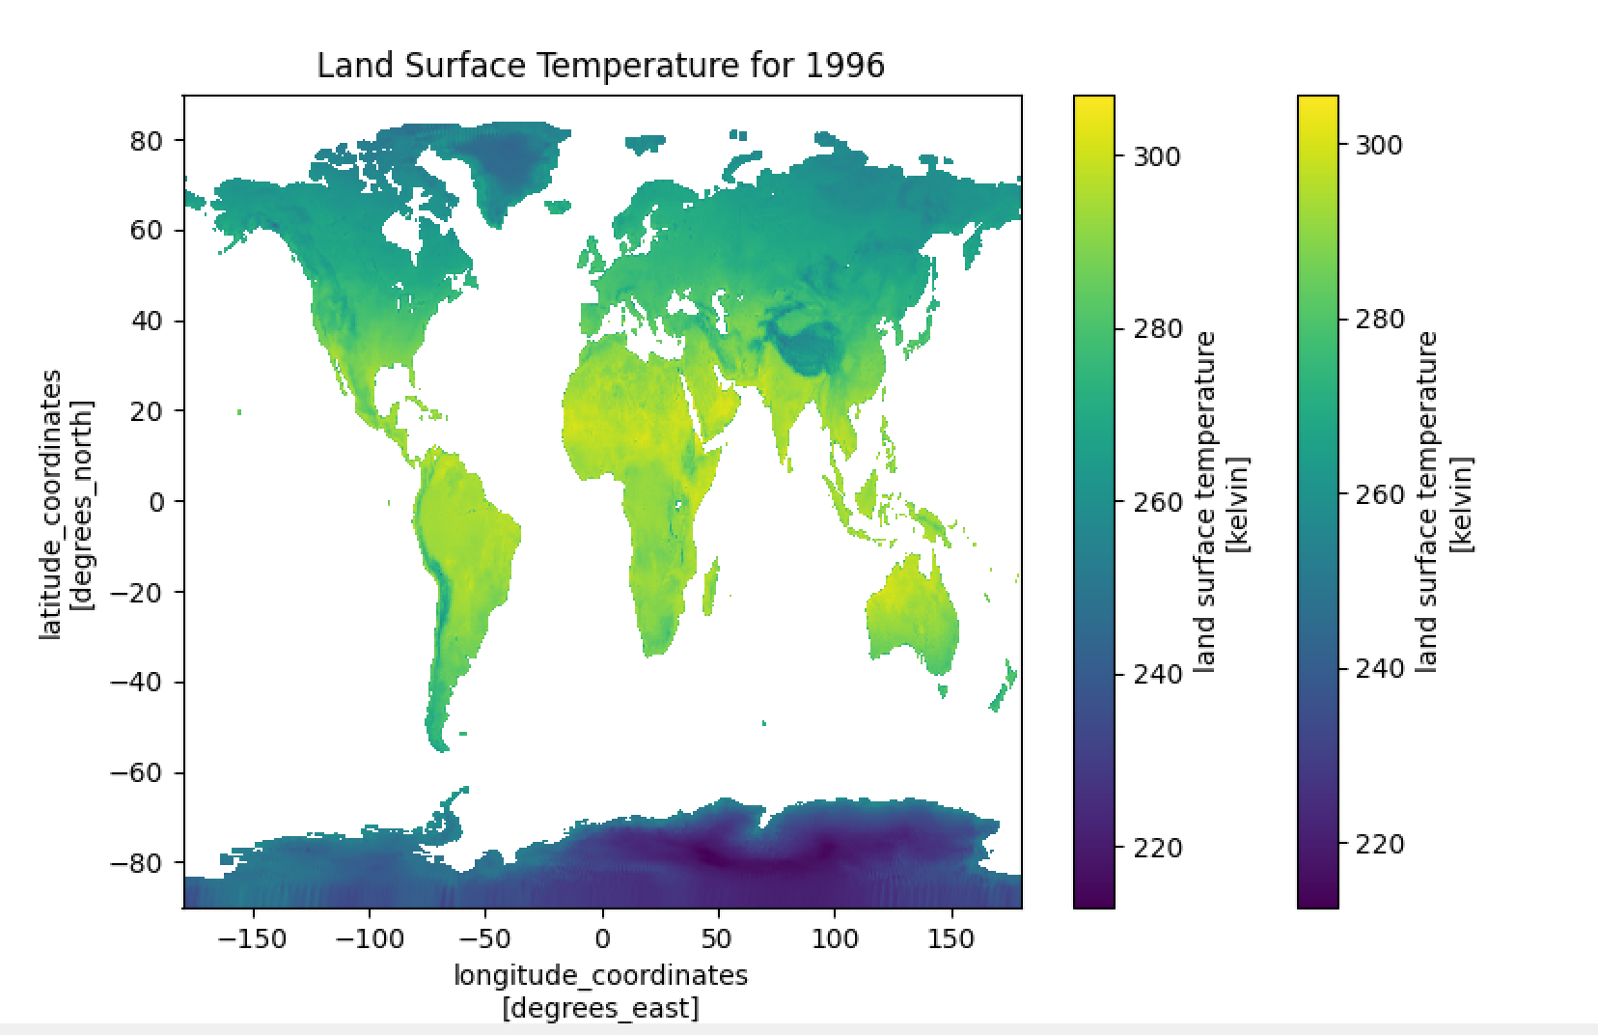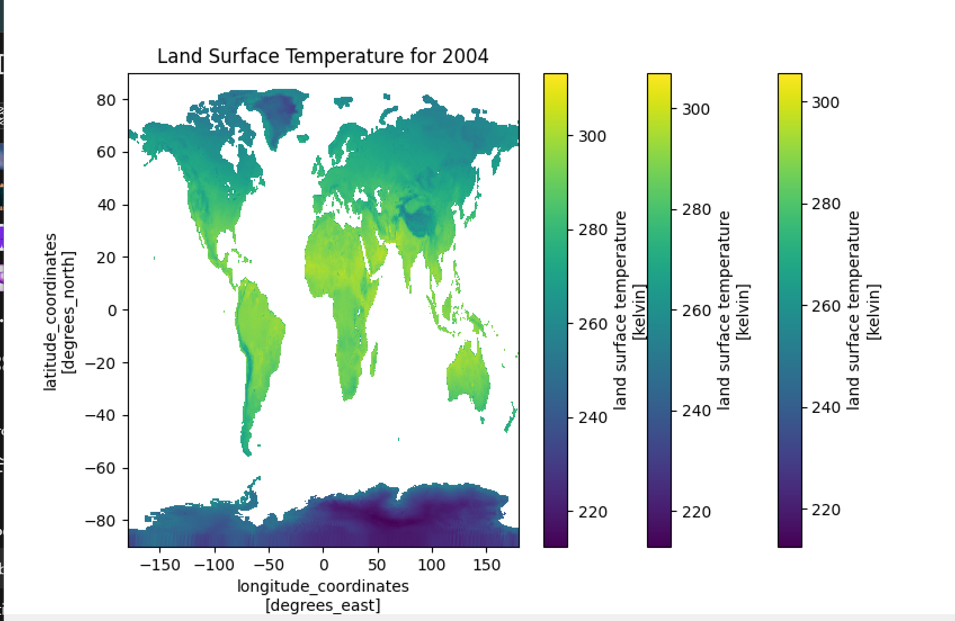
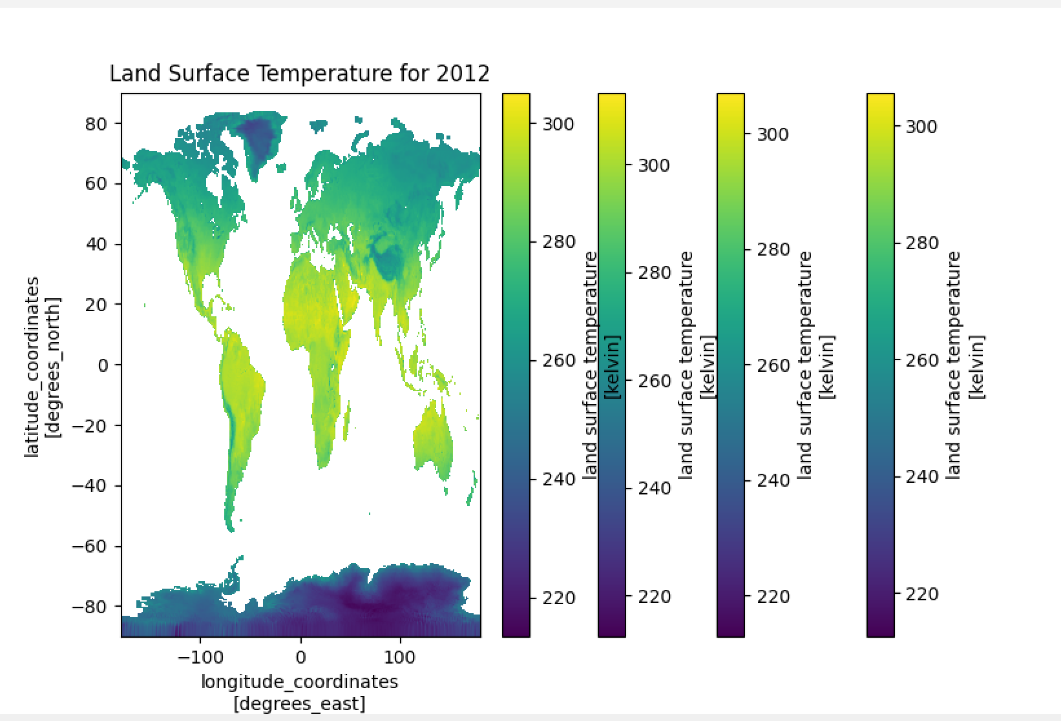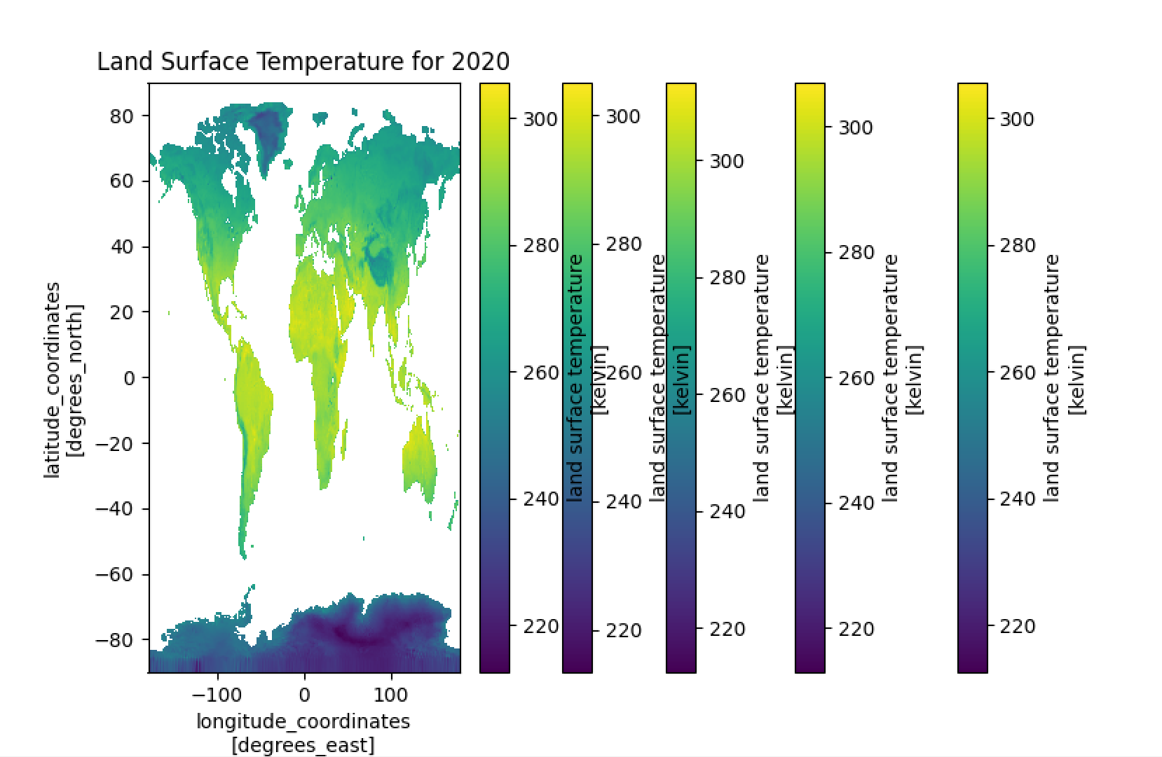
Figure 1: Global land surface temperature visualizations for selected years (1996, 2004, 2012, and 2020), using ESA satellite data. The color scale ranges from ~220K (purple/blue) to ~300K (yellow), revealing a progressive warming trend over time across multiple continents, particularly in the mid-latitudes and equatorial regions.
Global Mean Temperature Trend
Year | 1996 | 2020
Mean LST | 265.55 K | 266.35 K
This marks an approximate increase of 0.8K over the 24 years, reinforcing a steady warming trend observed globally.

Validation and Testing
Standard validation procedures were carried out to assess the dependability of the ARIMA model used to forecast land surface temperature (LST):
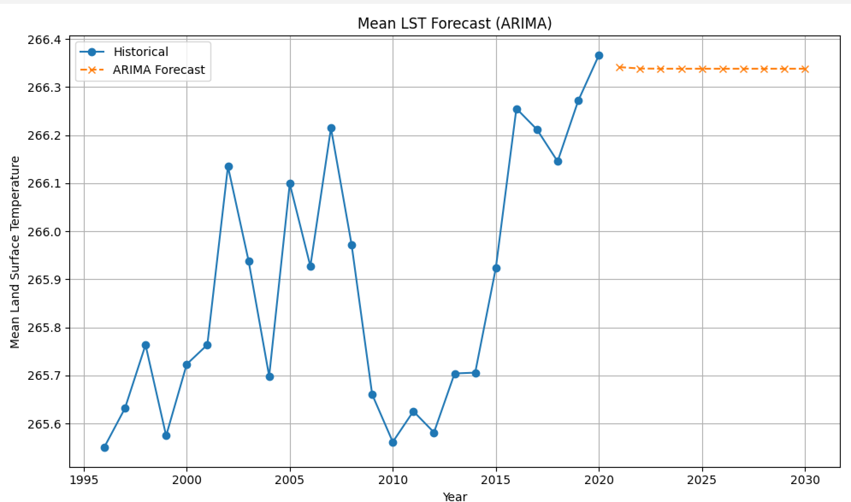
Figure 2: Forecast of global mean land surface temperature (LST) using an ARIMA(1,1,1) model. Historical values from 1996 to 2020 are shown in blue, while projected values from 2021 to 2030 are shown in orange.
Train-Test Split: A training set (1996–2018) and a test set (2019–2020) were created from the dataset. This made it possible to evaluate the model's short-term predictive performance using data that had not yet been seen.
- Residual Analysis: There was no discernible autocorrelation in the ARIMA model's residuals or the variations between the actual and predicted mean LST values, suggesting that the model fit the data well.
- Error Metrics: The model's forecasting consistency was confirmed by the low Mean Absolute Error (MAE) for the test set (you can enter the precise MAE here if it was computed).
The ARIMA(1,1,1) model was evaluated through several validation steps to assess its reliability in forecasting land surface temperature trends. A train-test split was performed by using data from 1996 to 2018 for training and reserving 2019–2020 for testing. This approach allowed for unbiased evaluation by simulating real-world prediction scenarios and ensured that the model was not simply overfitting past data. The residual analysis revealed no significant autocorrelation, indicating that the model effectively captured the structure in the historical series and did not leave systematic patterns unmodeled. Furthermore, a low Mean Absolute Error (MAE) during the test period confirmed that the model’s predictions closely aligned with observed values, reinforcing its accuracy. These validation results demonstrate that the ARIMA model is effective in identifying consistent temperature patterns and producing reliable forecasts under similar conditions. However, as discussed later in the report, these forecasts should be interpreted cautiously, as ARIMA does not account for the complex, nonlinear drivers of climate change.
Discussion and Conclusions
The investigation into Land Surface Temperature (LST) data from 1996 to 2020 has further shown its consistency and measurable global warming trend: a drift toward warmer temperatures, au contraire, in most affected regions-again, Asia, North America, and parts of Africa. This is also shown through the global mean LST, which increased by about 0.8 Kelvin in 24 years. The application of the ARIMA(1,1,1) model is therefore considered to be a practical effort in forecasting future temperature trends based on past data. While his forecast predicts that surface-level temperatures might not change into a plateau next decade, but must be seen with caution. While ARIMA models are useful for linearly detecting trends, they fall short in terms of fully understanding the more complex and nonlinear dynamics of climate, influenced by greenhouse gas emissions, deforestation, and policy interventions. While this limitation exists, the model itself provides a strong baseline and sends time series forecasting into the sphere of environmental monitoring. Future research efforts could include alternatively using more advanced modeling techniques, or in general, adding other significant exogenous variables, as one approach that would achieve greater predictive performance.
In conclusion, this project demonstrated the value of using satellite data and statistical modeling for monitoring and forecasting changes in Earth's surface temperature. By analyzing ESA's NetCDF-formatted LST dataset, we were able to visualize global temperature patterns over the past few decades and build a predictive model estimating future trends. The results show considerable increases in land surface temperature from 1996 to 2020, in line with worldwide concerns about climate change. The predictions by the ARIMA model, albeit limited, indicated that this warming trend might continue or stabilize shortly. These results point to the need for long-term climate data collection, as well as providing open-access visual means of delivering scientific information. The development of a non-technical user interface enhanced people's capability to work with and interpret complex datasets. In a nutshell, this study will further climate awareness and set the groundwork for follow-up research that can build in wider environmental indicators and more sophisticated machine learning techniques for accuracy enhancements.

Word Cited
[1] European Space Agency. 2024. Land Surface Temperature Climate Change Initiative (LST_cci). Retrieved April 28, 2025, from https://catalogue.ceda.ac.uk/uuid/785ef9d3965442669bff899540747e28
[2] D. Ghent, J. S. Anand, K. Veal, and J. Remedios. 2024. The Operational and Climate Land Surface Temperature Products from the Sea and Land Surface Temperature Radiometers on Sentinel-3A and 3B. Remote Sensing, 16, 18 (September 2024), 3403. DOI: https://doi.org/10.3390/rs16183403
[3] R. Kotharkar, A. Bagade, and S. Raut. 2021. ARIMA Modeling for Forecasting Land Surface Temperature and Determination of Urban Heat Island Using Remote Sensing Techniques for Chennai City, India. Arabian Journal of Geosciences, 14 (2021), Article 1515. DOI: https://doi.org/10.1007/s12517-021-07351-5
[4] Z.-L. Li, R. Tang, Z. Wan, and Y. Zhang. 2023. Satellite Remote Sensing of Global Land Surface Temperature: Current Status and Perspectives. Reviews of Geophysics, 61, 3 (2023). DOI: https://doi.org/10.1029/2022RG000777
[5] NASA Earth Observatory. 2009. Observing the Earth from Space. Retrieved April 28, 2025, from https://earthobservatory.nasa.gov/features/ObservingEarth
Appendix
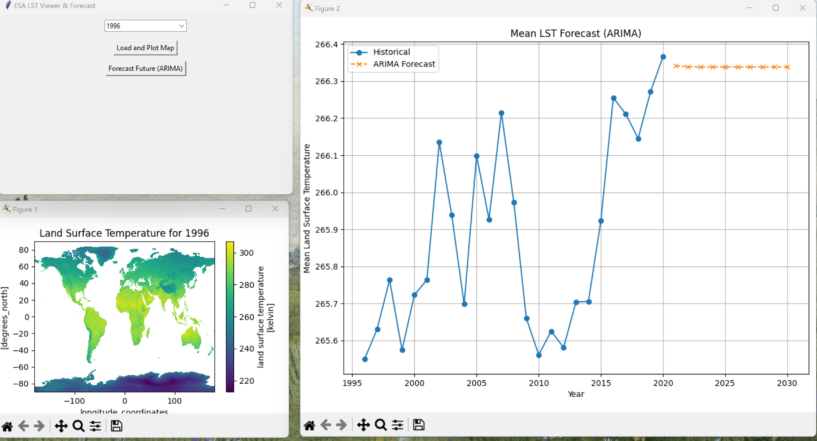
Appendix A: LST Viewer & Forecast GUI

